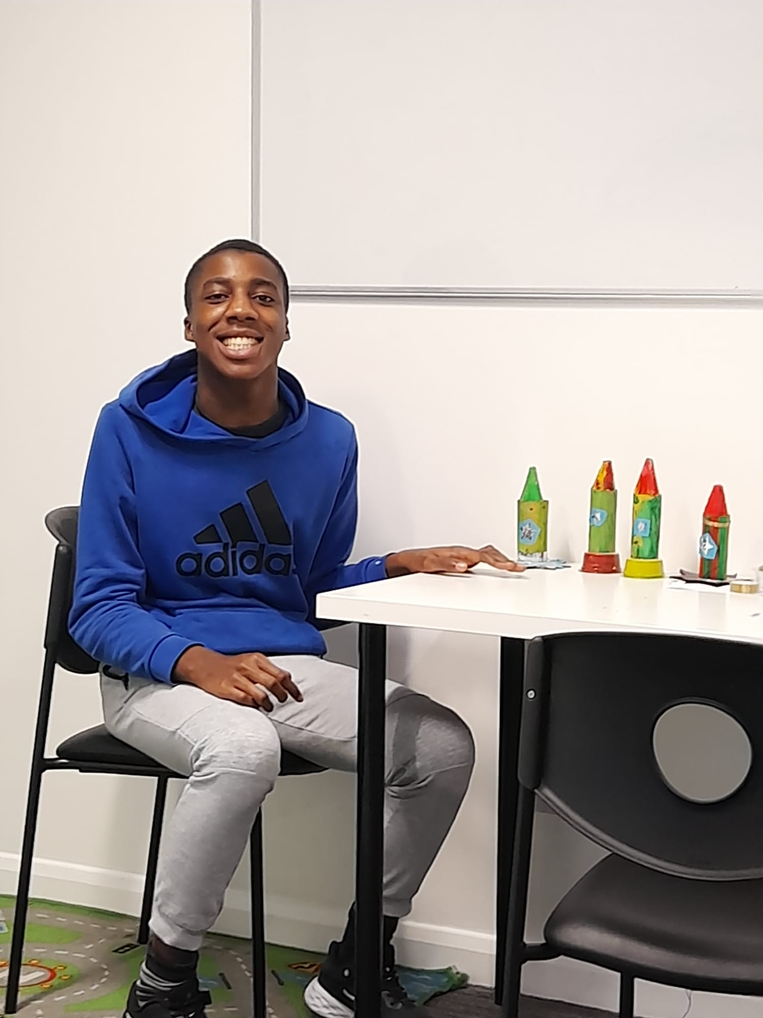
Our School
The Bridge SEN School News


Fortnightly News: 20TH January 2023
2019
Welcome to The Bridge SEN School Newsletter
Welcome back to all our students, staff members, parents and shareholders from the Christmas and New year holiday, I hope you all had a restful break. I am optimistic that this this new year will yield good fruit for everyone and it will be the best year in our lives. The learners have all returned to school with smiling faces and they are very excited to be back. Don’t let this cold snap hold you back, lets enjoy the New Year!
-Edith Eneanya-Bonito – Principal

Educational
The learners are back to school happy and they are settling in very well. These past few weeks the learners have been engaged with lot of sensory activities and educational activities like finger painting, colouring, cooking skills, exploration of collage, money recognition, bowling, fine motor skills and lot more. A new learner also joined the school after the break and he is settling in well with the environment.

Imminent Publication of 2023 School Prospectus

In preparation for our proposed relocation, The Bridge SEN School is already designing a new prospectus for the academic year 2023/2024 and will be published very soon. This is also a guide on the school new curriculum and timetable as well as an examination of the activities going on in school. Furthermore, this updated prospectus describes other developments that have been made by the school in the past years. The prospectus is expected to be uploaded on the school website before the end of January.
World Autism Month
As it is known, every April 2nd is world Autism Awareness Day. So, this year Autism Speaks celebrates the 15th annual world Autism Awareness Day. This will begin with an United Nations-sanctioned world Autism Awareness Day on April 2nd. Throughout the month of April, a lot of activities will be done starting from sharing stories and providing opportunities to increase understanding and acceptance of people with autism, fostering worldwide support. Autism Speak quoted that “this year would be committed to creating a world where all people with Autism can reach their full potential”. To read more and know how supporters can participate: check Here. Source: (Autism Speaks)

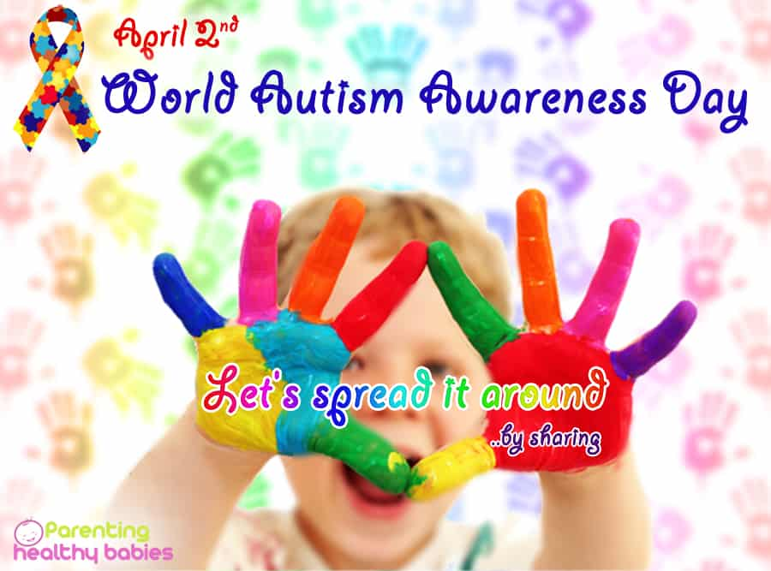

The Bridge SEN School runs an ASD Activity Club on Saturdays, 10am to 4pm. There are lots of activities available for young learners within the ages of 16 to 25 years. These activities range from bowling, snooker, photography club, Art and Crafts, Museum visits, Cooking, Interior Decoration, etc. We receive referrals from members of the public and local authorities; please contact the school on admin@thebridge-school.co.uk or Tel: 02077038587

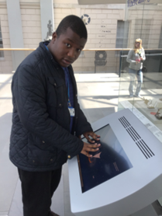


Activities & Advice

Winter Friendly Activities For
Autistic Children
We may have noticed that young people with autistic may find it difficult to attend and concentrate on activities that they are not particularly interested in, and this can be very challenging! With the developmental delay in the areas of joint attention and other core features of the diagnostic criteria for Autistic Spectrum Disorder (ASD), it is expected of a child with ASD not to be focused during an undesired activity.
Key Factors to Consider:
- For young people with Autism, multi-sensory materials are very important especially when they are engaged in an activity.
- Other things that could be distracting should be avoided.
- Endeavour to make sure the activity has some appeal or that the young person is aware a reward may come afterwards.
Here are some fun and engaging activities that can be helpful for children with Autism during this winter:
- Shaving foam and Baking Soda ‘Snow’.
- Building Snow People.
- Painting on Ice.
- Dressing up as a Snowman during ‘The Snowman’, Snowman’s Story.
- Sensory water Bottles
- Spinning and Dancing Snowman
You can also read more using this link Here.
Source:(Autism Spectrum Teacher)

Christopher Boone
Christopher Boone is the young
Protagonist of The Curious Incident of
the Dog in the Night-Time by Mark
Haddon. He is an autistic 15-year-old boy who attempts to solve the mystery of death of the neighbor’s dog, Wellington. Christopher faces a number of obstacles to find his mother and catch the murderer. The book is told in the first person and deeply examines the through process of an autistic person observing ad attempting to make sense of the world around them.
Christopher is very intelligent, especially in mathematics. He also has a great photographic memory and is a keen observer. However, he struggles to understand facial expressions, save for happiness and sadness, but only because he was taught. He doesn’t understand metaphors or jokes either and has a distinct dislike of the colour yellow. The book doesn’t turn him into a figure to be pitied, but instead uses the autism perspective to evoke comedy and pathos from the narrative.

Wales Cheerleader Hopes to Inspire More Boys.
A young man, Brad by name, who is 19 years of age from Cardiff was the only male member of Team Wales’ advanced adaptive abilities side that also won last year’s world championship. He does his trainings daily which includes weight sessions and monthly with Wales. He has struggled to convince his friends to get involved as they “still think it is all about pompoms”. He made his decision about cheerleading after watching his sister, Freya, in action. He said “people have taken the mick out of me”. However, he has also said being part of the team has made him acquire “super strong arms” and helped him cope with his ADHD. Brad, who is undergoing training to become a plumber in a college, has started inspiring other boys to join the Welsh squad in 2023. The full version of this story can be viewed Here.
Source: (BBC News)

A New feature, where we examine fictional representations of autistic people.
T
The learners are happy to resume the activity centre and have been engaged with lot of activities like colouring, painting, puzzles, cooking, baking, board games and also bus rides to bowling centre. Many of the clients that joined over the holiday are getting settled now and enjoying the activities being carried out in the centre. Activity Co-ordinator

The Bridge SEN School admits students all through the academic year between the ages of 14-25. If you are interested in placing a student at the school or obtaining more information, please contact admin@thebridge-school.co.uk or Tel:02077038587
Our Activities Centre

THE BRIDGE ACADEMIC CALENDAR
EDUCATION
- Half term 13th January
- End of term 3rd April
( Please visit our website: www.thebridge-school.co.uk for full Academic Year 2022/2023 Calendar)
ACTIVITY CENTRE
Our activity centre in Thornton Heath is open throughout the year,
Except on Bank Holidays.

COVID 19
We are in regular contact with the local authorities to ensure that we react appropriately and in a timely fashion to any development. We observe the most up-to-date rules concerning COVID 19.
- Weekly tests are carried out on learners and staff
- Social Distancing measures are in place
- Regularly handwashing is mandatory
- NHS Track and Trace QR Code are signposted around the school.
- Face masks are worn throughout classes
Our Full Policy is available on our Website

OPENING TIMES AT LIRAL VEGET COLLEGE LONDON
Liral Veget College Limited is the sister company of Right Support Management, under which The Bridge SEN School is now operating. We offer a variety of English language courses, After School Club and Life in the UK Preparation classes. Our current opening times are 8.30am – 18.00pm Monday to Friday and 10.00am - 14.00pm on Saturdays.
Academic Manager - James Nuttall.

Drawings/Pictures of the month

QUOTE OF THE FORTNIGHT
‘If a man empties his purse into his head, no man can take it away from him. An investment in knowledge always pays the best interest’.
-Benjamin Franklin.
We publish our newsletter fortnightly. Copies will be emailed to you and made available on the school’s website (https://www.thebridge-school.co.uk/our-school). Thank you for your feedback. If you would like to contribute to our newsletter, please email me at admin@thebridge-school.co.uk -


